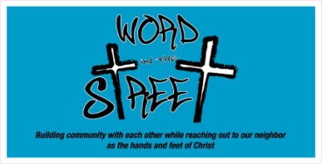
Word on the Street
2018 -2019 Registration Form

W.O.T.S. Member Information:

Name: ________________________________________ Grade: _______________

Home Phone: ___________________ Cell Phone: ____________________________

Email: _________________________________________

Mailing Address: _____________________________________

_____________________________________

Parent Information:
Name: _______________________________ Cell: ________________________

Email Address: ________________________________________________________________

Are you available during the day for driving? Yes / No (circle)

In the event of an emergency and a parent is unavailable, who should we contact?

Emergency Contact (other than parent): _______________________Cell: ____________________

Address: ______________________ City/State: __________________ Phone: _________________

Is there any information that would be helpful to the W.O.T.S. staff? (allergies, illness, visual or hearing impairments, or particular sensitivities, etc.)
__________________________________________________________________________________________________________________________________________________________________________

I give permission for my child to be photographed for St. Michael’s website, the newspaper, or other publications. Yes / No ___________ (initial)

I give permission for my child to be driven by any adult involved with St. Michael’s program, Word on the Street. I understand it maybe be different adult each time, depending on the size of the group and the outing. This permission slip is only good for the 2018 - 2019 W.O.T.S. year.

_____________________________________________ _________________________
(Parent’s Signature) (Date)

Snack Fee for the year ($25.00) Pd._________

W.OT.S. T-shirt ($10.00) Pd. _________
(optional)
(please indicate size (adult sizes) S M L XL
(circle choice)

