Saint Michael's Parish
2018 - 2019 First Reconciliation & First Communion Information

First Reconciliation…
December 15th at the church from 8:45 - 10:15.
Students need to be accompanied by a parent. This is a beautiful morning designed to be meaningful for both you and your child.

First Communion Retreat…
Saturday, March 23rd from 9:00 to Noon @ the Parish Community Center
This event is for students but parents should return at 11:30 for Closing Prayer Service

First Communion
Saturday, May 11th @ 10 AM and Noon

10 AM Mass - Mrs. Dowd's Class and Mr. & Mrs. LaMondia's Class

Noon Mass - Mrs. O'Sullivan's Class and Mrs. Vigneux's Class

Rehearsal Dates and Times - Students must attend both of their rehearsals.

Assigned Dates/Times are as follows:
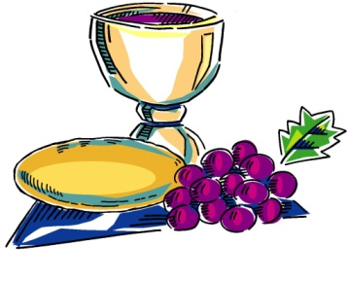
10 O'Clock Mass
Mon. May 6th @ 6-7:30 p.m.
Wed. May 8th @ 6-6:45 p.m.

Noon Mass
Tues. May 7th @ 6-7:30 p.m.
Wed. May 8th @ 6:45-7:30 p.m.

Attire for First Communion:
Girls: White dress, white tights or socks, white shoes. Veil optional.
PLEASE NO GLOVES OR PURSES.

Boys: White shirt (long or short sleeves), white tie, black pants, dark dress shoes.
PLEASE NO SUIT JACKETS during the ceremony.

