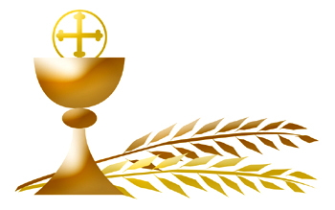
First Communion Information

Date of First Communion:

Child’s Name:
(First) (Middle) (Last)
Street Address:

City/Town, State, Zip

Father’s Full Name
(First) (Middle) (Last)
Mother’s First & Maiden Name:
(First Name) (Maiden Name)

Complete Date of Baptism:
(Month) (Day) (Year)

Church of Baptism

City/Town, State, Zip

If your child was NOT baptized at St. Michael’s please include a copy of their baptismal certificate. If you do not have one in your possession, you must contact the parish where they were baptized.

Baptismal certificates can be faxed to St. Michael’s Parish: (413) 525-2443
Attn: Religious Education Office
scanned to email: stmikereled@gmail.com
or mailed to: St. Michael’s Religious Education Office
53 Somers Road
East Longmeadow, MA 01028

Baptismal certificates can also be dropped in the locked mailbox at
the Religious Education Office - 53 Somers Road.

