Saint Michael's Parish
2020
First Reconciliation & First Communion Information

First Communion:
Saturday, October 3rd @ 10 AM and Noon

10 AM Mass - Mrs. Dowd's Class and Mr. & Mrs. LaMondia's Class
Noon Mass - Mrs. O'Sullivan's Class and Mrs. Vigneux's Class

Rehearsal Dates/Times are as follows: Students must attend both of their rehearsals.
All rehearsals take place at the church.

10 O'Clock Mass
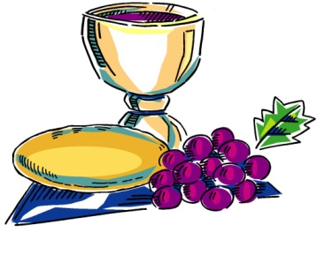
Monday, September 28th @ 6-7:30 p.m.
Wednesday, September 30th @ 6-6:45 p.m.

Noon Mass
Tuesday, September 29th @ 6-7:30 p.m.
Wednesday, September 30th @ 6:45-7:30 p.m.

Reader Rehearsal:

10:00 Mass Readers - 5:30 on Wednesday, September 30th

12:00 Mass Readers - 7:30 on Wednesday, September 30th

Offertory Rehearsal:

10:00 & 12:00 Mass both on Thursday, October 1st from 4:15 to 5:00

Attire for First Communion:

Girls: White dress, white tights or socks, white shoes. Veils are optional.
PLEASE NO GLOVES OR PURSES at the ceremony.

Boys: White shirt (long or short sleeves), white tie, black pants, dark dress shoes.
PLEASE NO SUIT JACKETS at the ceremony.

